
Camp Letter 1 – Join us to Sweden!
What?
Summer camp 2026 – Jamboree26 Sweden
When?
25 juli–1 augusti 2026
Where?
Norra Åsum, Kristianstad, Sweden. We travel by [TRANSPORTATION].

It’s time to start dreaming about next summer’s grand adventure – the Swedish National Scout Jamboree: Jamboree26! For an entire week at the end of July, all of [SCOUTSTADENS SCOUTKÅR] and thousands of other Scouts from all over Sweden (and the world!) will gather at the Norra Åsum field outside Kristianstad for a camp filled with friendship, adventure, and mates.

THIS TEMPLATE IS WRITTEN FOR SWEDISH TROOPS AND AUTOMATICALLY TRANSLATED INTO ENGLISH. SOME PARTS MAY NOT BE RELEVANT TO AN INTERNATIONAL TROOP PARTICIPATING IN JAMBOREE26, AND SOME VITAL PARTS FOR YOU MAY BE MISSING.

PLEASE ADJUST TO YOUR NEEDS, AND DISREGARD ANY STRANGE WORDINGS OR TRANSLATION ERRORS.

THANK YOU.

What is Jamboree26?
Jamboree26 is a national jamboree, meaning a camp for all Scouts in Sweden, regardless of collaboration organisation or focus. In Sweden, national jamborees are held every four years. National jamborees provide an opportunity for all of us Scouts in Sweden to experience the breadth and depth of Scouting together, as well as to meet and get to know new friends from across the country. These jamborees are also a chance for the movement to test new methods and ideas that we do not have the opportunity to develop or implement in our regular activities, so at a jamboree you can experience Scouting in ways you may never have encountered before.

How do we travel?
We in [SCOUTSTADENS SCOUTKÅR] will be travelling to Jamboree26 together. The journey there will be by [MODE OF TRANSPORT] and will take approximately [TRAVEL TIME] hours. Once on site, we will have a campsite for our group where we will live and eat, possibly together with another group. We’ll take part in the programme within our usual divisions and patrols. When there are no scheduled activities, there will be more freedom to wander around in smaller groups, explore the hubs (one for each age group) with plenty of spontaneous activities and cafés, visit the main square, or come up with your own activities together with new and old friends from our group or some of our neighbouring campers.

A day at Jamboree26
At Jamboree26, the morning is set aside for scheduled activities, during which you will participate with your usual section. The programme at Jamboree26 is tailored to each age group and is based on the five areas of development in the Scouts’ programme: the mind, the body, feelings, the group, and life’s big questions. Afterwards, we return to our campsite for lunch.
In the afternoon, the different age-group hubs are open, offering plenty of fun spontaneous activities and cafés where you can hang out, have fun with your friends, and meet new people from other groups. There will also be various main squares, a camp shop, and different exhibitors.
In the evening, the hubs are usually open as well, but there may also be other activities, such as the opening show, campfire, or the “Together Party”.

Cost and Registration
As a Scout or leader, you register using [SCOUTSTADENS SCOUTKÅR]'s registration form, which you can find here:
https://anmälningsformulärsadress
Registration opens on [OPENS] and the last day to register is [CLOSES]. The cost for Jamboree26 is:
- Participant: [FEE] kronor
- Leader: [FEE] kronor

The fee covers both the camp fee for Jamboree26, the travel costs to the camp with the group, and the group’s equipment at the camp, such as tents and cooking gear. We want everyone to be able to join in, so if you find it difficult to afford the fee, we recommend various ways to apply for support, for example Majblomman or the Scouts’ Support Fund. Speak to your leader and they will help you further.
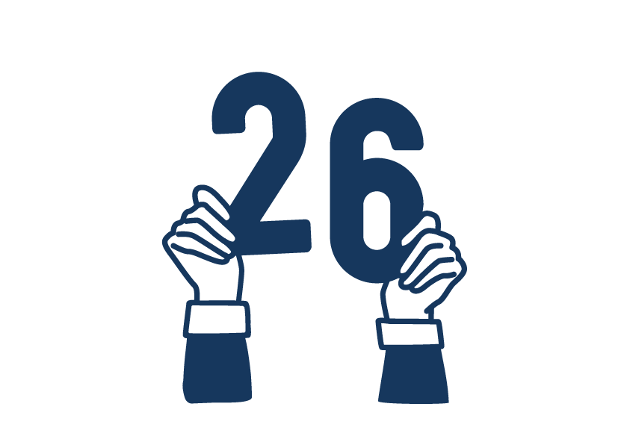

We’ll see you next summer in Sweden!
Tip!
Wish Jamboree26 for Christmas.

